1

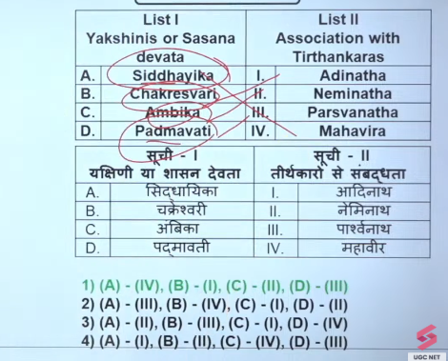

2
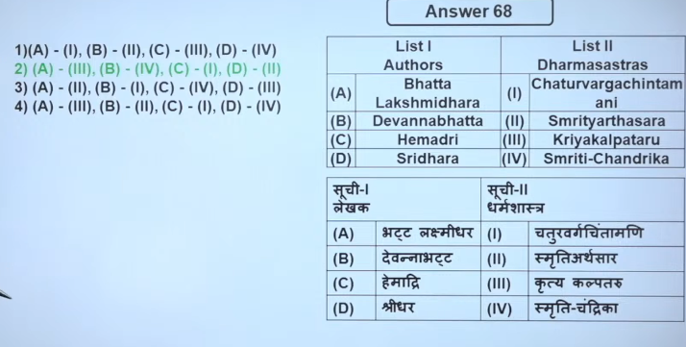
3
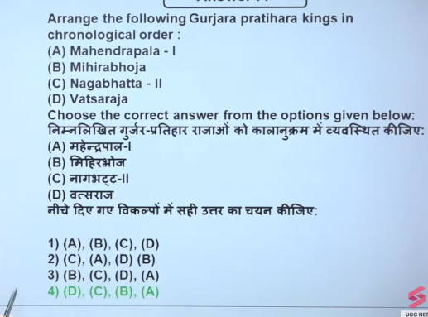
Vatsaraja was a prominent Gurjara-Pratihara king who reigned during the late 8th century, with his time period generally recognized from roughly 780 to 800 AD. As the son of Devaraja and grand-nephew of Nagabhata I, he significantly expanded the empire into North India, established his capital at Ujjain, and was a key player in the early Tripartite Struggle for control of Kannauj.
- Nagabhata I (c. 730–760): Real founder, expanded empire from Gujarat to Gwalior.
- Vatsaraja: c. 780 – 800 CE
- Nagabhata II: c. 800 – 833 CE
- Mihir Bhoja (Bhoja I): Ruled approximately 836–885 CE. He was the son of Ramabhadra and a major expander of the empire, often called "Adivaraha".
- Mahendrapala I: Ruled approximately from 885 – 910 CE. He was the son of Mihira Bhoja and presided over the expansion of the empire, with his reign being a high point for art and literature under the poet Rajasekhara.

4

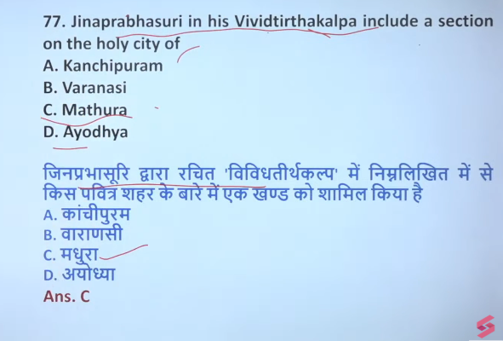

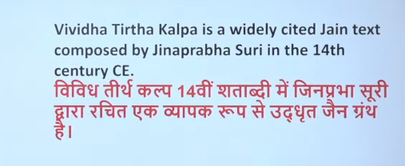

5
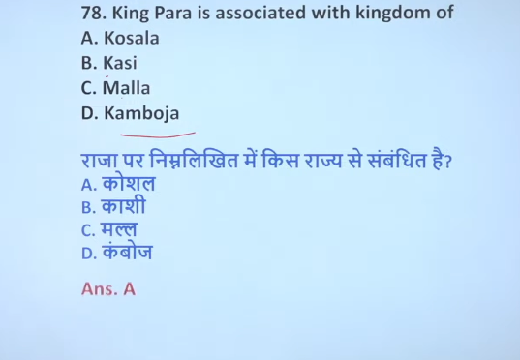
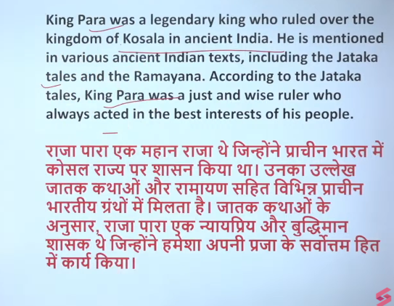

6
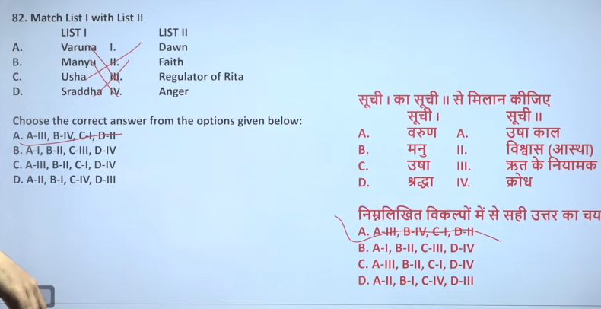
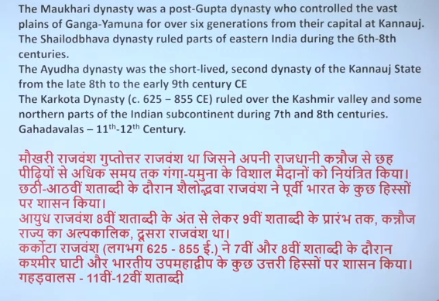

7
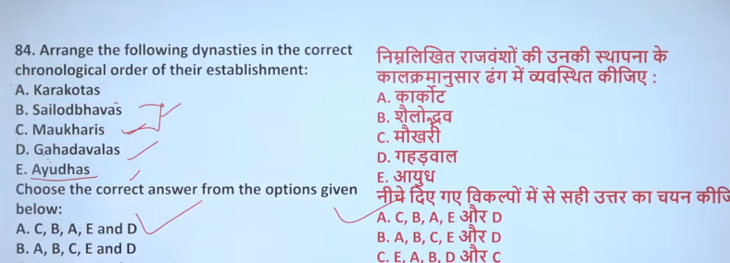
The Ayudha dynasty (often referred to as the Ayudha dynasty of Kannauj) ruled in North India, specifically in Kannauj, during the late 8th to early 9th century, roughly spanning from c. 770 to c. 816 CE.
Key Details of the Ayudha Dynasty:
- Time Period: c. 770 – c. 816 CE.
- Location: Kannauj (Uttar Pradesh).
- Context: The dynasty was a short-lived ruling power that emerged after the fall of Yashovarman and during the transition period before the Gurjara-Pratihara dynasty took full control of Kannauj.
- Key Rulers:
  - Vajrayudha (c. 770–783 CE): Established the dynasty.
  - Indrayudha (c. 783–791 CE): Deposed/ruled during this period.
  - Chakrayudha (c. 791–816 CE): Installed as a client king, often serving under the influence of the Pala Dynasty of Bengal.
- Fall: The Ayudha dynasty was finally succeeded by the Pratihara dynasty.
Note: The results also mention the Ay dynasty of southern Kerala, which was a distinct entity, ruling from the early historic period (2nd century CE) into the medieval period, particularly known as a "buffer state" between 9th–10th centuries CE

The Gahadavala dynasty ruled parts of present-day Uttar Pradesh and Bihar in North India, with capitals at Varanasi and Kannauj, primarily during the 11th and 12th centuries CE, roughly from 1072–1237 CE. The dynasty was established by Chandradeva (r. c. 1089–1103) in the late 11th century and reached its peak under Govindachandra.
Key details regarding the dynasty include:
- Establishment: The dynasty was founded around 1072–1089 CE following the decline of the Kalachuri dynasty.
- Peak Period: The most powerful ruler, Govindachandra, ruled from roughly 1114–1155 CE, expanding the empire and holding off invaders.
- Downfall: The dynasty declined after the last powerful king, Jayachandra, was defeated and killed by the Ghurids in 1194 CE.
- End: While power shifted after 1194, the dynasty lasted until around 1237.
The Maukharis were a prominent North Indian dynasty that ruled roughly between the 6th and 7th centuries CE, reaching their peak power following the decline of the Gupta Empire. They established their capital at Kannauj, with prominent kings like Ishanavarman (ascended c. 554 CE) ruling until the early 7th century, when they were absorbed by Harsha's empire.

The Karkota dynasty ruled the Kashmir valley and surrounding regions from approximately 625 CE to 855 CE. Founded by Durlabhavardhana, the dynasty reached its peak in the 8th century under Lalitaditya Muktapida (r. c. 724–760 CE), transforming Kashmir into a major military and cultural power. The dynasty is recognized as a Golden Age of Kashmiri history.

8
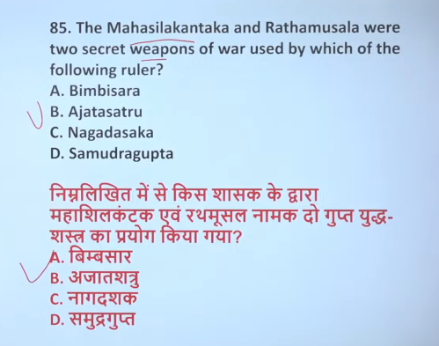

9 Ans: B
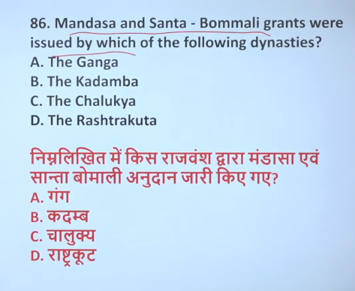

Mandasa और Santabommali grants का संबंध Kadamba dynasty से माना जाता है, क्योंकि इन्हें Kadamba chiefs (स्थानीय शासकों) द्वारा जारी किया गया था।
- उस समय उस क्षेत्र पर Eastern Ganga dynasty का overlordship (सर्वोच्च सत्ता) था।
- इसलिए grants में Ganga rulers का भी उल्लेख मिलता है।
इसलिए relation ऐसे समझें
- Issuer (grant देने वाले) → Kadamba chiefs
- Overlord / supreme ruler → Eastern Ganga dynasty
Mandasa & Santabommali grants → Kadamba chiefs under Eastern Ganga rulers
Mandasa और Santabommali के grants (inscriptions / copper-plate grants) Eastern Ganga dynasty द्वारा जारी किए गए थे।
- ये दोनों land grants / inscription records हैं।
- ये आज के आंध्र प्रदेश के Srikakulam क्षेत्र में मिले हैं।
- इनसे पता चलता है कि उस समय Eastern Ganga rulers मंदिरों और ब्राह्मणों को भूमि दान देते थे।
Mandasa grant + Santabommali grant → Eastern Ganga dynasty

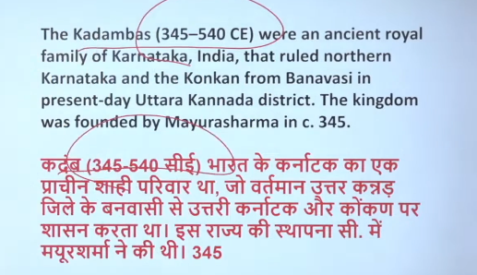

10
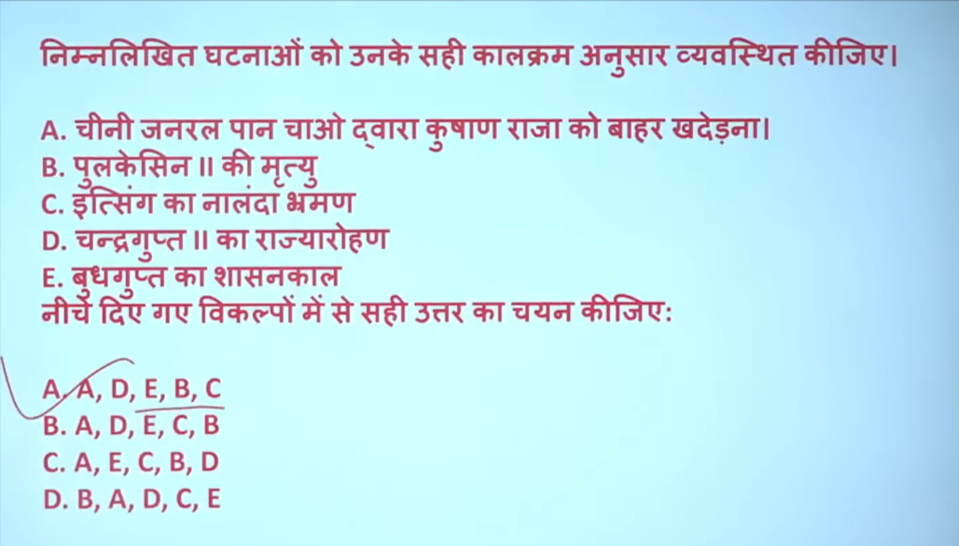
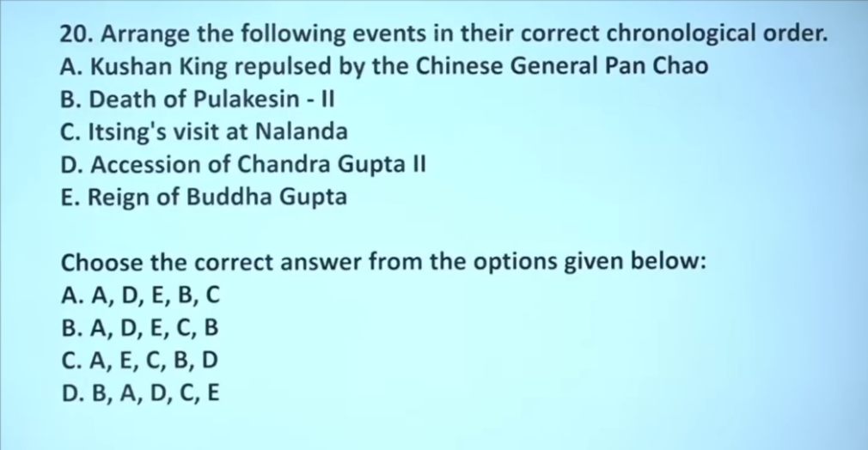

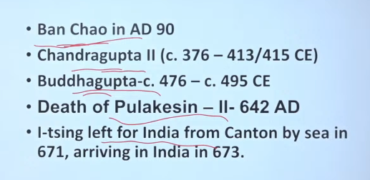

11
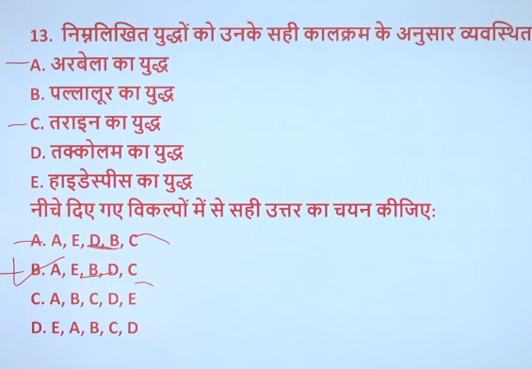
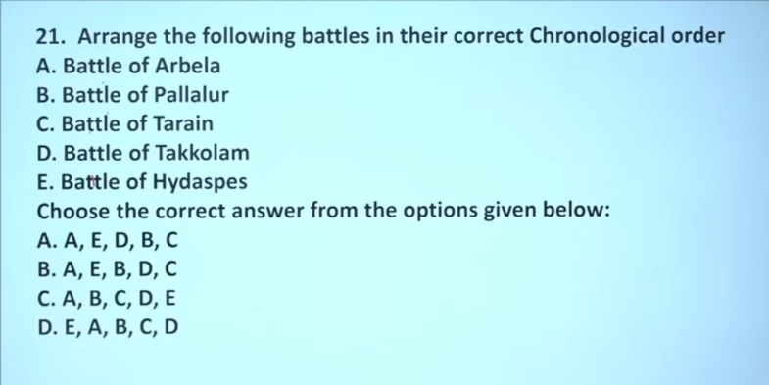
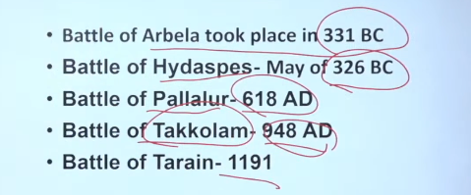
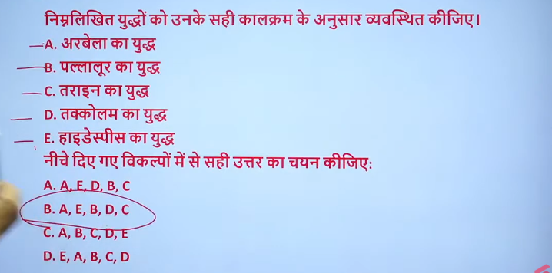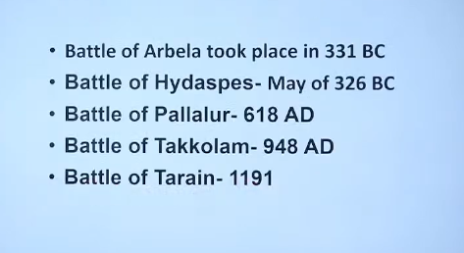

12
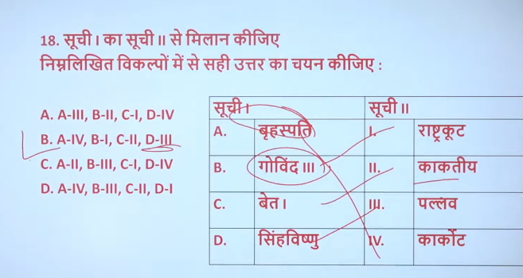
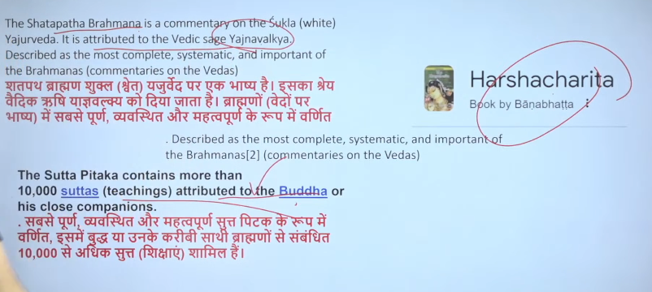
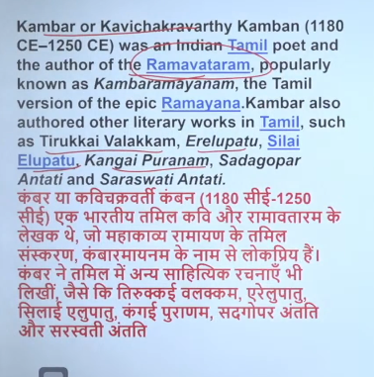
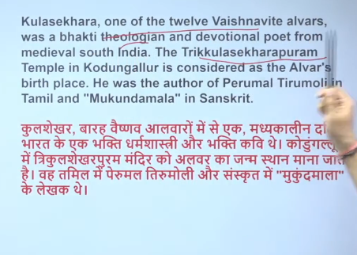
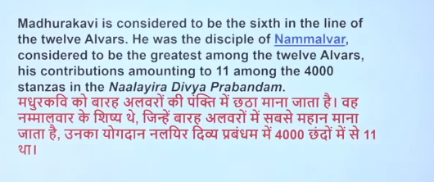

13
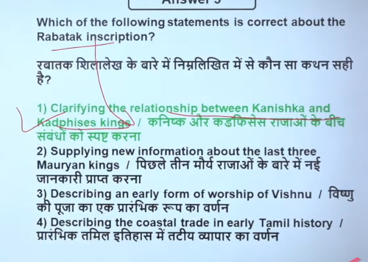
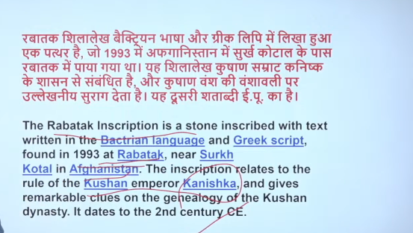

14
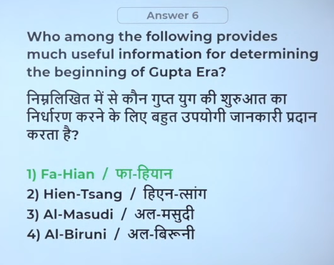
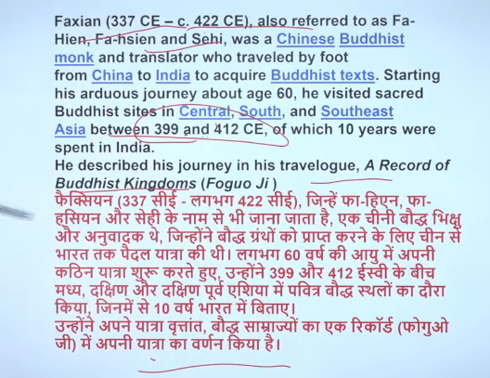
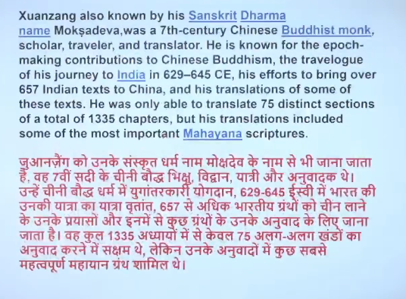
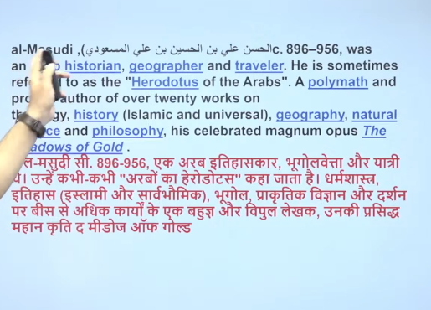

15
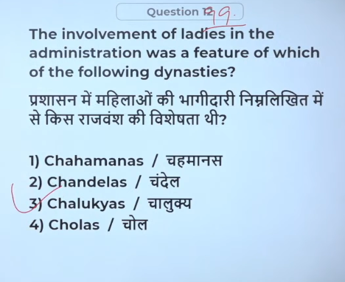

16
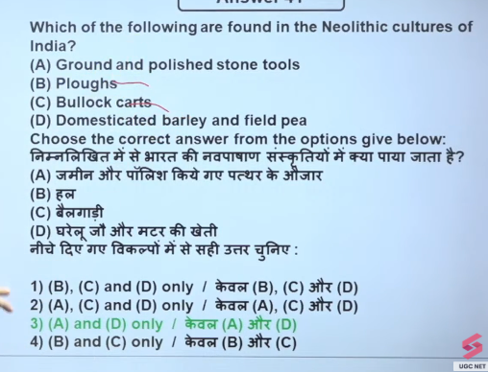

17
